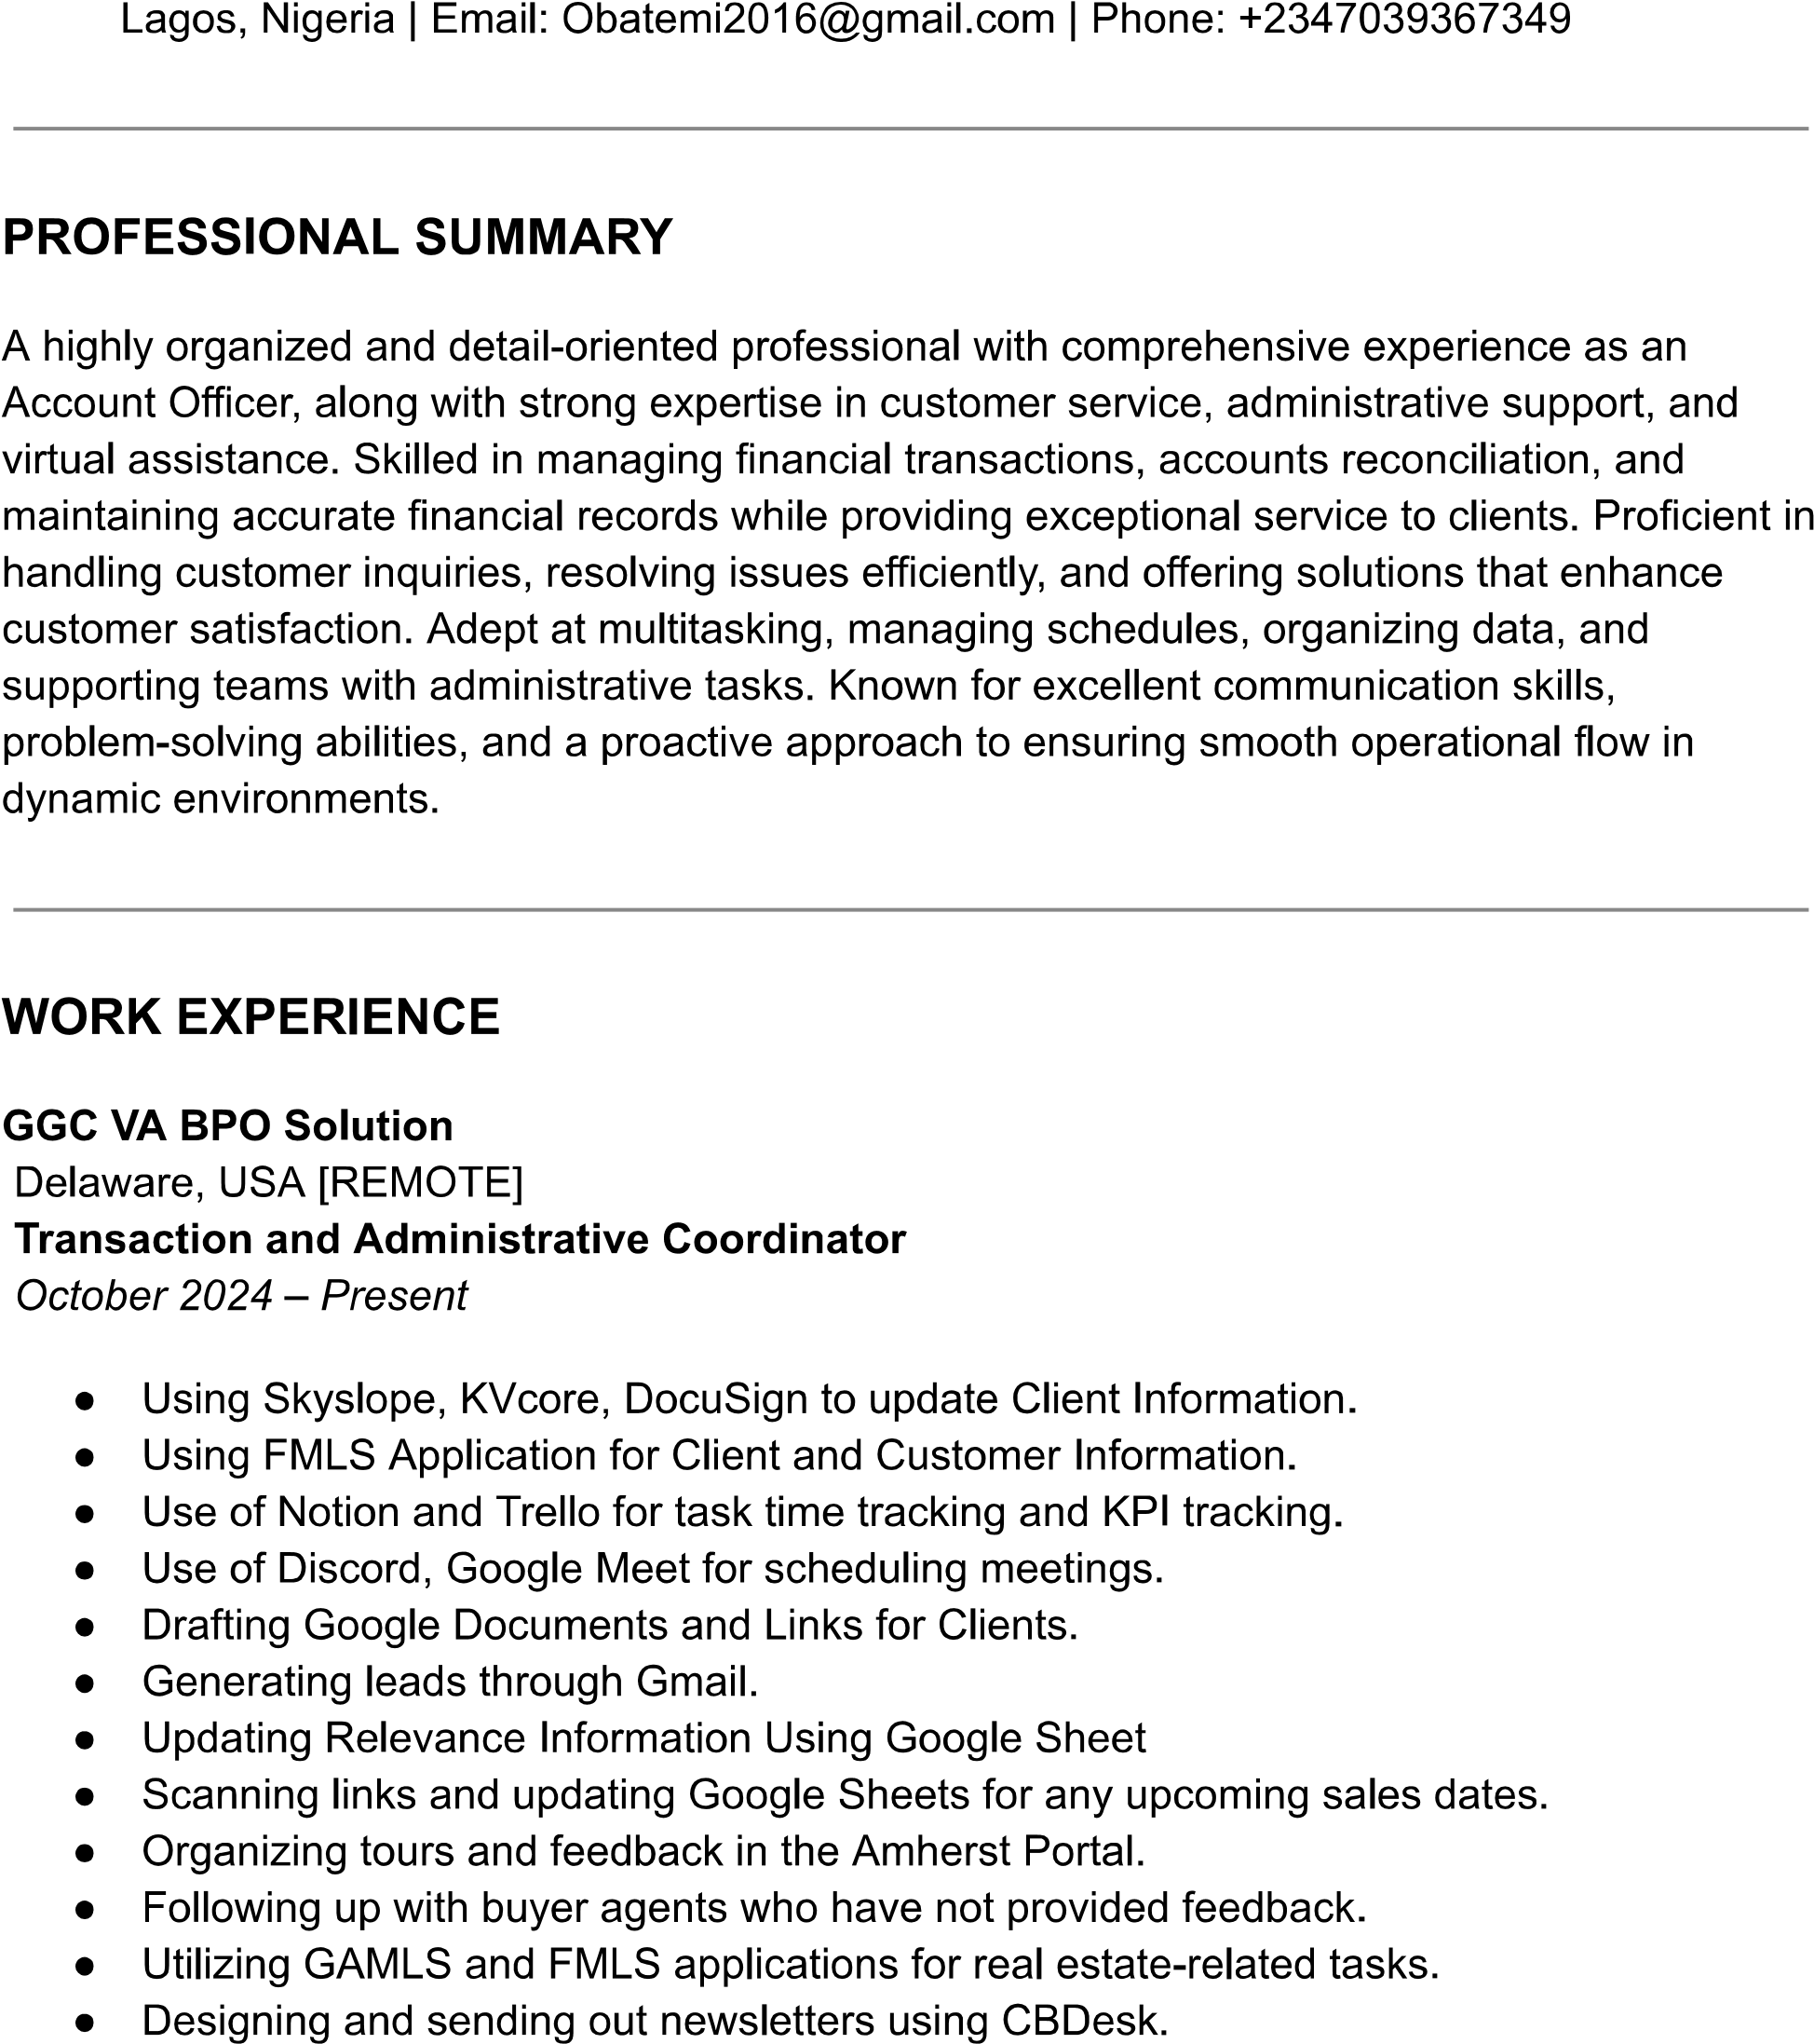

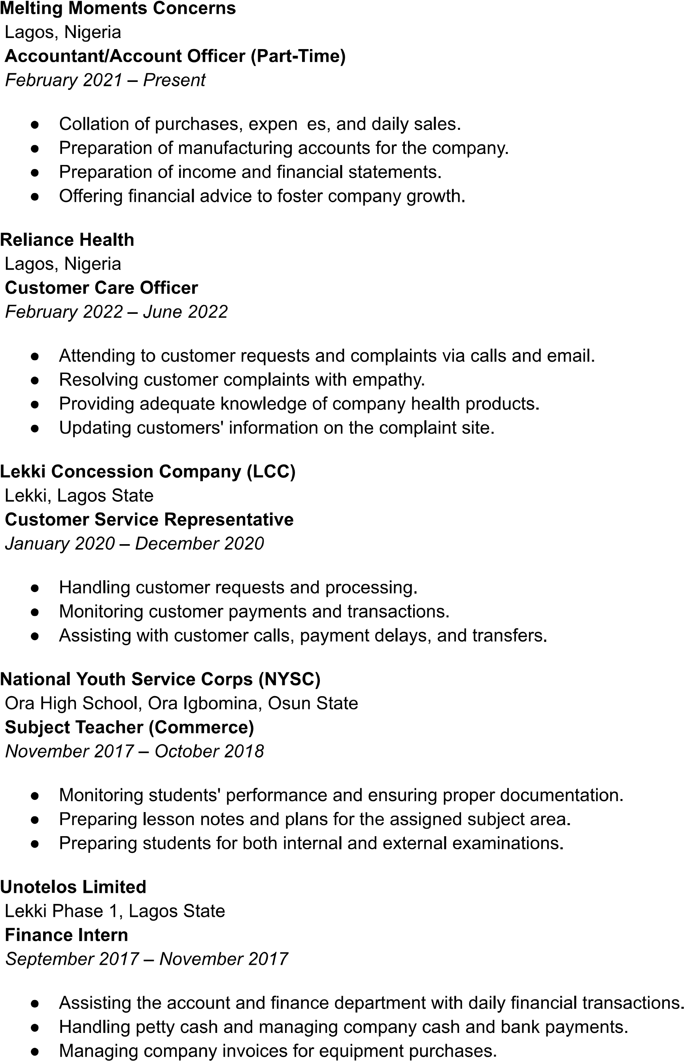

**EnergySwitch Alliance Limited  
*Account Officer*  
📅 May 2025 – Present**

* Prepare and maintain accurate financial records, including ledgers, journals, and statements.
* Record all financial transactions (accounts payable, accounts receivable, payroll, etc.) into the accounting system.
* Ensure compliance with accounting principles and company policies.
* Reconcile bank statements, credit card statements, and other accounts to ensure accuracy.
* Prepare month-end, quarter-end, and year-end closing entries.
* Review and resolve discrepancies or issues related to accounts.
* Prepare accurate financial reports, including balance sheets, income statements, and cash flow statements.
* Assist in the preparation of budget forecasts, financial projections, and variance analysis.
* Perform any other responsibilities as assigned by management.

